71. Editing editable template in AEM.

There are 3 modes in template editor.

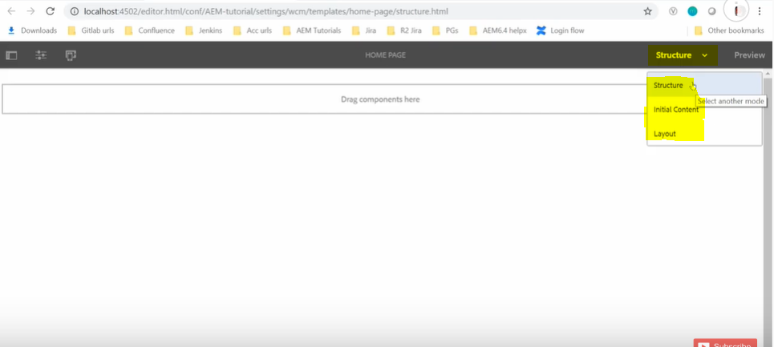

1. Structure mode: It is for building structure with the components. Here components can be locked or unlocked. When components are locked, you can add content but page author can't edit the component. You can unlock the component to allow you to define the initial content which bring us to the initial content mode.

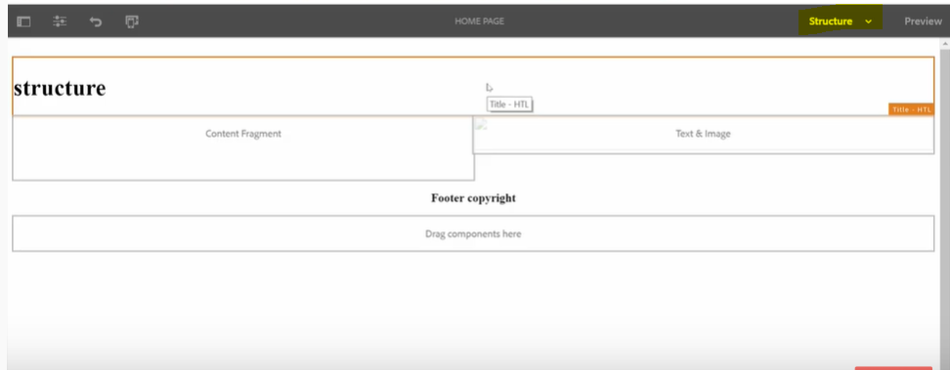

2. Initial content mode: In this mode you can define the initial content of a component if it's unlocked and that will be copied to any page based upon this template.

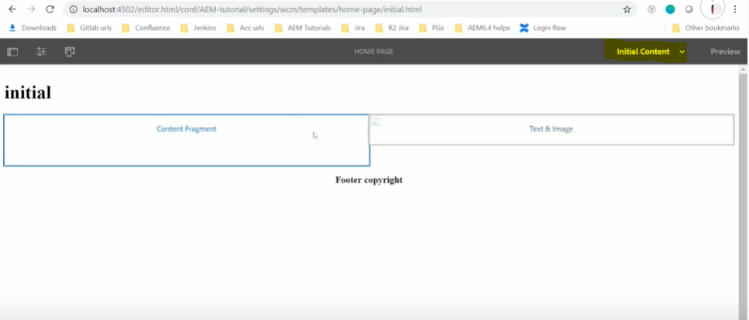

3. Layout mode: Here you can predefine the template layout for the different devices.

